Math 110 Coursepack Supplement

by Andrew Ross, Eastern Michigan University

updated 2015-09-02

Contents

Studying Advice 1

Big Numbers and Scientific Notation 2

Chapter 1.3: Estimation 3

Chapter 1.5: Compared to What? 4

Chapter 2.1: Direct Proportions 5

Chapter 2.4: Inflation 8

Ch 2.7 Inverse Proportions 12

Chapter 3.5: Fitting Linear Models to Data 13

Chapter 4.1: Piecewise Linear Models 14

Chapter 5.3: Expected Value 16

Chapter 6.1: Histograms 16

# Studying Advice

First, keep this in mind:

<http://www.huffingtonpost.com/2014/07/15/barrowford-school-letter_n_5588988.html>

A school district sent home a letter to parents that said:

 tests do not always assess all of what it is that make each of you special and unique. ..  
[tests do not show whether ] you can be trustworthy, kind or thoughtful, and that you try, every day, to be your very best… the scores you get will tell you something, but they will not tell you everything.

Retrieval Practice  
<http://www.retrievalpractice.org/RetrievalPracticeGuide.pdf>  
  
<http://www.scientificamerican.com/article/what-are-the-best-and-worst-ways-to-prepare-for-an-exam/>  
  
also see  
http://www.scientificamerican.com/article/education-why-cramming-gets-a-c  
  
<http://www.scientificamerican.com/article/researchers-find-that-frequent-tests-can-boost-learning/>

<http://ideas.time.com/2013/01/09/highlighting-is-a-waste-of-time-the-best-and-worst-learning-techniques/>

<http://www.vox.com/2014/6/24/5824192/study-smarter-learn-better-8-tips-from-memory-researchers>

# Big Numbers and Scientific Notation

If your calculator or spreadsheet shows something like 3.2E5 or 3.2E05 or 3.2E+05, don't ignore the E ! The E (or sometimes little-e) means "times ten to the", so 3.2E5 is 3.2 * 105 or 320,000. You can think of it as moving the decimal point 5 places to the right. Do NOT think of it as adding 5 zeros, because the number of zeros to add depends on where the decimal point is already. Similarly, if there is a -5 instead of a 5 or +5, that means to move the decimal point to the left instead of the right.

Scientific notation is nice and systematic. It seems a shame to have to spend time learning the not-so-systematic system of thousands/millions/billions/trillions, but it is something we need to do to understand many important numbers in society.

First, let's get these established:

1 million = 1 M = 1 thousand thousand

1 billion = 1 B = 1 thousand million

1 trillion = 1 T = thousand billion (note, we use T for Trillion; for thousand you should use k, like kilo, instead of t)

It is handy to be able to translate from scientific notation to thousands/millions/billions/trillions without having to use all of the zeros. This table will help you do that.

|  |  |  |  |
| --- | --- | --- | --- |
| 1E3= | 1 k |  | 1,000 |
| 1E4= | 10 k |  | 10,000 |
| 1E5= | 100 k |  | 100,000 |
| 1E6= | 1 M | = 1 thousand k | 1,000,000 |
| 1E7= | 10 M | = 10 thousand k | 10,000,000 |
| 1E8= | 100 M | = 100 thousand k | 100,000,000 |
| 1E9= | 1 B | = 1 thousand M | 1,000,000,000 |
| 1E10= | 10 B | = 10 thousand M | 10,000,000,000 |
| 1E11= | 100 B | = 100 thousand M | 100,000,000,000 |
| 1E12= | 1 T | = 1 thousand B | 1,000,000,000,000 |
| 1E13= | 10 T | = 10 thousand B | 10,000,000,000,000 |

# Chapter 1.3: Estimation

Here are the numbers you will often need to know. Memorize the first 3 in particular AND put them on your note sheet for all exams.

US Population: 310 Million in August 2010, but let’s call it 300 Million

World Population: 6,865,668,780 in August 2010, but let’s call it 7 Billion

US Households: 114,825,000 in 2010, but let’s call it 100 Million

World households: 1.9 Billion in 2009 (from <http://www.timesonline.co.uk/tol/sport/olympics/article6256063.ece>)

Michigan population: 10 million

Metro Detroit area population: 5 million

You might try organizing that into a table. It would be good to put on your note sheet for exams.

# Chapter 1.5: Compared to What?

When we say to compare one thing to another that includes it (e.g. Detroit to Michigan, or Michigan to the USA), there is a common mistake people make: if we are talking about the Michigan budget deficit, it is not included in the federal budget deficit. The federal budget deficit does not include any state budget deficits (many people think it is just the sum of all 50 state deficits). As an analogy, consider a set of parents who make $50k in a year but spend $52k that year; their deficit is $2k. If their 14-year-old made $200 by babysitting that year but spent $250, that $50 deficit is not included in the $2k of the parents.

Also, be careful with the words “deficit” and “debt”. The deficit is the shortfall in this year’s budget alone, while the debt is, roughly speaking, the accumulated deficits from all previous years together.

When coming up with things to compare to, it is best to change only one aspect of the situation at a time. For example, if you start with Michigan spending on prisons in 2009, you could compare to Ohio spending on prisons in 2009, or Michigan spending on education in 2009, or Michigan spending on prisons in 2008, but it would be a stretch to compare Michigan 2009 prison spending to Ohio 2008 education spending. Similarly, try to stay in the same general field as where you start. If Michigan spent hundreds of millions of dollars on prisons, it wouldn’t be helpful to say how many baseball players that could pay for. Saying how many teachers it could pay for would be better, but still not great, since it’s not as if all that money would be routed toward teachers even if it was sent toward education.

If you are given a ranking (what is the #1 cause of something?) there are two good ways to make sense of it. First, ask: out of how many options? #1 out of 3 is a lot less important than #1 out of 100, for example. Also, ask if it is nearly tied with the items nearby it, or if there is a big gap.

If you are trying to compare the US to other countries, you almost always have to adjust for population. There are no countries with a population close enough to the US that you can avoid the adjustment. In particular, the biggest countries are: (as of 2010-2012, depending on the country)

China 1.347 B

India 1.210 B

EU 500 M (the European Union, or EU, is not a country, but if you treat it like one, it would fit here)

US 313 M

Indonesia 237 M

Brazil 192 M

Pakistan 179 M

Nigeria 162 M

Russia 143 M

Consider this article. Does it have any flaws in the way it is written?

https://www.causeweb.org/wiki/chance/index.php/Chance_News_105#Data-mining_birth_month_and_disease

And also consider “You Are Most Likely to Die at 11 a.m.”

<http://www.theatlantic.com/health/archive/2012/11/you-are-most-likely-to-die-at-11-am/265427/>

If an average is given and then a specific data point to show that something is above or below the average, we should ask: compared to what sort of spread? Or compute a percentile. For example,  
  
<http://www.mlive.com/news/ann-arbor/index.ssf/2014/05/ann_arbor_school_custodians_ex.html#incart_m-rpt-2>  
says  
"...AAPS pays about $1.11 in custodial salaries per square of instructional space, while the 2012-13 state average is about $0.73 per square foot."  
  
[first of all, we should account for cost-of-living index in the region; Ann Arbor is a bit more expensive than other areas of the state?]  
  
We can't expect every district's custodial salaries to be at or below the average, right?

# Chapter 2.1: Direct Proportions

A typical test to see if something is a direct proportion is to take the data you have, divide each y value by its x value, and look at the ratios. For example,

|  |  |  |
| --- | --- | --- |
| x | y | y/x |
| 2 | 0.666667 | 0.333333 |
| 3 | 1 | 0.333333 |
| 4 | 1.333333 | 0.333333 |
| 5 | 1.666667 | 0.333333 |
| 6 | 2 | 0.333333 |
| 7 | 2.333333 | 0.333333 |

Since all of the y/x ratios are the same, we know this is an exact direct proportion (and, the constant of proportionality is 0.33333). This is nice when it happens, but real data is rarely that nice. What if you had this table?

|  |  |  |
| --- | --- | --- |
| x | y | y/x |
| 2 | 0.62 | 0.310 |
| 3 | 0.87 | 0.290 |
| 4 | 1.47 | 0.368 |
| 5 | 1.83 | 0.366 |
| 6 | 1.83 | 0.305 |
| 7 | 2.54 | 0.363 |

Here, the y/x values are all approximately equal to each other, so we might say that it’s an *approximate* direct proportion. After all, the graph does look approximately like it would be a straight line that would touch the origin. This is a good idea, but it turns out there is something we need to be careful of. Consider this data table, of income amounts and resulting income tax amounts (taken from Chapter 3.1, though that’s a bit of a leap forward in the textbook):

|  |  |  |
| --- | --- | --- |
| Income | Tax amt. | Tax/Income |
| $ 30,000 | $ 640 | 0.021 |
| $ 31,000 | $ 679 | 0.022 |
| $ 32,000 | $ 718 | 0.022 |
| $ 33,000 | $ 757 | 0.023 |
| $ 34,000 | $ 796 | 0.023 |
| $ 35,000 | $ 835 | 0.024 |

Note that tax/income is essentially what overall fraction of your income you’re paying toward income tax, so we could have written that column as percents: 2.1%, 2.2%, 2.2%, 2.3%, etc. These numbers all look approximately equal to each other, but notice that they are steadily increasing, while in the previous example the y/x values had no clear increasing or decreasing trend. Are tax and income still approximately proportional? Let’s look at the graph:

While the data do look like they fall on a line, that line wouldn’t touch the origin. This means that it’s not a good idea to call it an approximate direct proportion, because it deviates from a straight-line-that-touches-the-origin *systematically* rather than *randomly*, as the previous example did. To summarize:

If the y/x ratios have a systematic trend (increasing or decreasing) as x increases, then the relationship is not even approximately directly proportional.

Exercise: Generate a table of values for y=10x+50 for x=1,2,3,4,5, then calculate y/x for each data point. Is this an exact direct proportion, an approximate direct proportion, or neither? Also graph the results.

# Chapter 2.4: Inflation

What sorts of prices tend to increase faster or slower than inflation? Here are some graphs to consider:

Crude Oil

<http://inflationdata.com/inflation/images/charts/Oil/Inflation_Adj_Oil_Prices_Chart.htm>

(is this a reliable web site?)

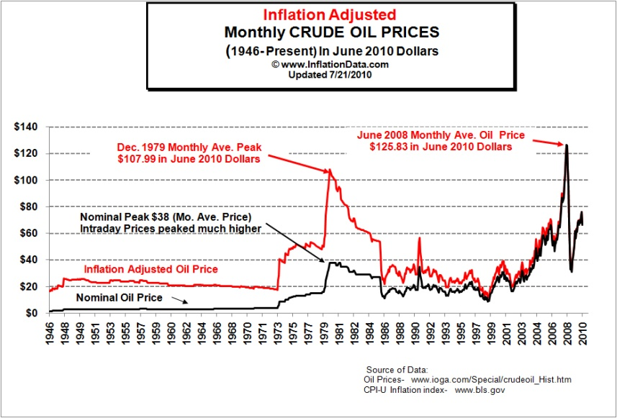

Health Care

<http://content.healthaffairs.org/cgi/content/full/hlthaff.w2.83v1/DC1>

<http://content.healthaffairs.org/content/vol0/issue2003/images/data/hlthaff.w2.83v1/DC1/Altman_Ex1.gif> (is this a reliable web site?)

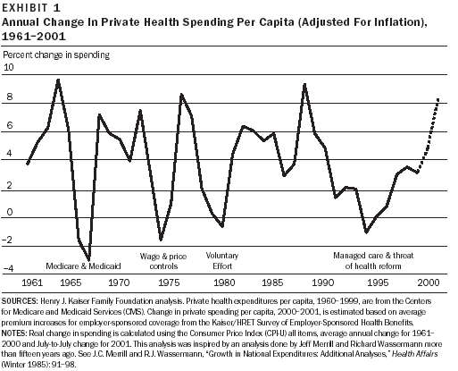

Gold Prices

<http://en.wikipedia.org/wiki/File:Gold_price_in_USD.png> (is this a reliable web site?)

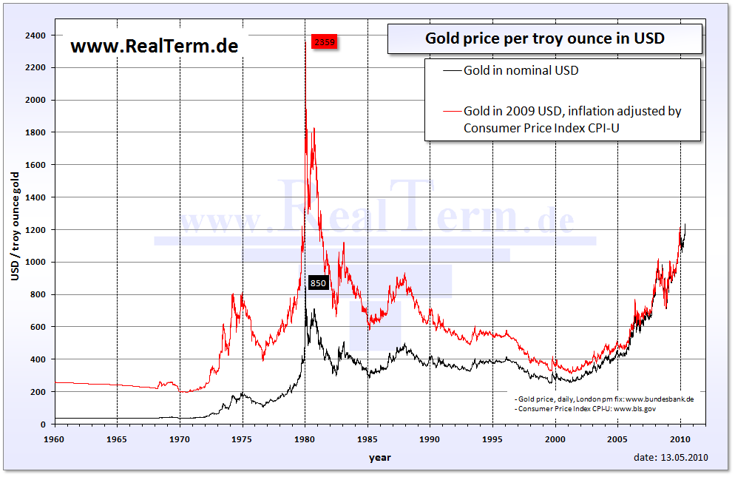

<http://www.sharelynx.com/chartsfixed/600yeargold.gif> (is this a reliable web site?)

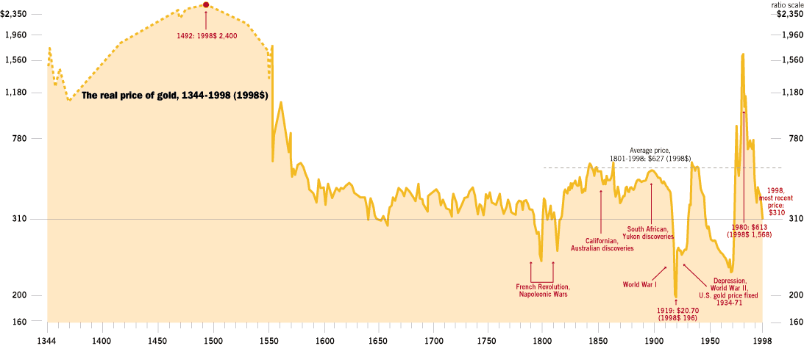

US Income

<http://en.wikipedia.org/wiki/Household_income_in_the_United_States>

[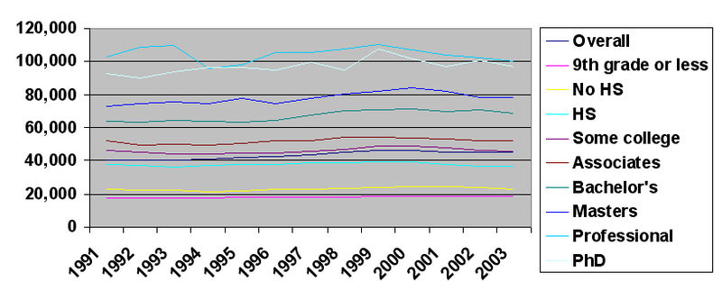](http://upload.wikimedia.org/wikipedia/en/e/e0/Income_Education_91_to_03.jpg)

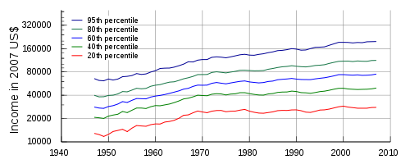

<http://en.wikipedia.org/wiki/Median_household_income>

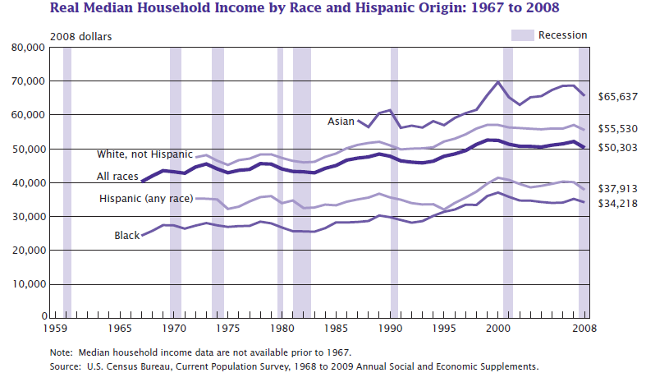

Electricity prices

<http://www.solarbuzz.com/SolarpricesUSA.htm> (is this a reliable web site?) 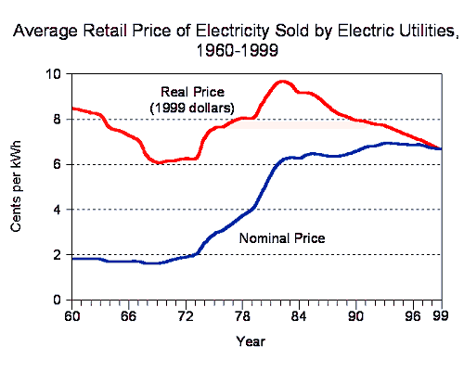

Advanced thoughts on how CPI is computed:

Don’t Let Economists and Politicians Hack Your Math

<http://www.slate.com/articles/technology/technology/2013/02/should_algebra_be_in_curriculum_why_math_protects_us_from_the_unscrupulous.html>

# Ch 2.7 Inverse Proportions

A fundamental application of inverse proportions is in sharing. For example, if 10 friends go out to eat and the total bill is $70, then each person's share is $70/10=$7. What if the group had spent $70 but it was only 5 people? Half as many people to share the same bill means each has to pay twice as much. This is the opposite of the "doubling property" that we like so much for direct proportions in Chapter 2.1. We could calculate $70/5=$14, but perhaps it is better to say "double the per-person share from $7 to $14".

Similarly, if the bill was still $70 but the group of 10 was instead a group of 20 (double its previous size), the per-person share would be half its previous size: $7/2 = $3.50 .

This has bigger implications in society than just going out to eat. Systems like Social Security for retired people or disabled people are, in some sense, working households banding together to share the cost of running the retired or disabled household. For example, about 4 million households receive SSI benefits (this is Supplemental Income, also called welfare, not retirement pensions) of about $10,000/year each. If there are about 80 million households supporting those 4 million households, that is 20 per 1 SSI household. So the per-household share is $10,000/20 = $500 per household. If in the long run we changed to 10 households supporting each 1 SSI household, then the per-household share would be $1000 instead of $500.

In equation form, we can write:

Each share = total amount / #people or households

This equation helps if the change isn't a nice one-half or one-third, for example. If the number of supporting households changed from 80M to 85M, we could say that each share is now $10k*4M/85M = $470 or so (the # of supporting households went up, so the per-household share went down).

The same thing can work if we use percentages instead of dollar amounts as the total. For example, each non-retired household pays about 12% toward Social Security pensions, and there are about 4 such households per retired household. If that ratio changes from 4-to-1 to 2-to-1 in the long run, then there are half as many supporting households, so the per-household share doubles from 12% to 24%.

If the ratio changes to 3-to-1, we might be tempted to think: 3 is the average of 2 and 4, so the per-person share should be the average of 12% and 24%, which is 18%. Here are two ways of seeing that is not the exact answer, though:

* We could switch from 4-to-1 at 12% to 1-to-1: cutting the ratio by a factor of 4 means we quadruple the per-house share from 12% to 48%. Then go from 1-to-1 to 3-to-1: tripling the number of households changes the share from 48% to 48/3 = 16%
* We could say: 4 households at 12% of income each amounts to 4*12=48% of one household income. That is, the retired household is living on just under half of an ordinary income. If we divide that 48% across 3 households now, we get 48/3= 16%

Of course these two ways of seeing it are pretty much the same.

We could translate from percentages to money if we want. If the average household income is $60k, then 12% of that is $7.2k. If 4 households each pay $7.2k, the total is $28.8k , which is 48% of $60k. If we divide the $28.8k by 3 houses now instead of 4, we get $9.6k each, or $9.6k/60k=16%.

# Chapter 3.5: Fitting Linear Models to Data

Do not use best-fit lines to model piecewise-linear systems like those we see in Chapter 4.1

Other words for correlation: link, relationship, association, correspondence, trend

Pick your Axes

When you have a data set, it’s often not clear what should be your “x” variable and what should be “y”. Here are some guidelines:

Put it on the horizontal axis:

* If we directly controlled or could directly control it (e.g. price of something we’re selling)
* If we think it is the “cause”, and the other variable is the “result”
* If it is a date/time value, e.g. 2007 or 12:43pm (a “when”)
  + but “3 hours” or “78 years of age” (a “how long”) could be either x or y.
* If it is the first in a sequence of measurements (e.g. 5th grade test score vs. 8th grade test score)

If neither variable is a clear choice to go on the horizontal axis, it might help to try the graph both ways and see if one interpretation makes more sense than another (“try it both ways”).

If there is no clear preference for one variable vs. the other, then maybe “it doesn't matter” (# people at WMU, #people at CMU)

There is a difference between "try it both ways" and "it doesn't matter". For “try it both ways”, we’re exploring the idea of one thing causing another or vice versa, but we aren’t sure which way the causation runs (and it might run both ways). For “it doesn’t matter”, we’re fairly sure that neither thing is causing the other.

Size of Correlation Coefficient

There are no hard-and-fast rules for how big an R value must be to be important. Here is a general guideline, appropriate for the social sciences (psychology, political science/public policy, etc.)

Correlation Coefficient Descriptor

0.0-0.1 trivial, very small, insubstantial, tiny, practically zero

0.1-0.3 small, low, minor

0.3-0.5 moderate, medium

0.5-0.7 large, high, major

0.7-0.9 very large, very high, huge

0.9-1 nearly, practically, or almost perfect

(from <http://www.sportsci.org/resource/stats/effectmag.html> )

The technical sciences (physics, engineering, etc.) typically have more strict requirements. Remember, even if there’s a large correlation, that doesn’t mean that one thing is causing the other. And, in particular, if you get a correlation of exactly 1.0, there’s a good chance you accidentally graphed some data against itself.

Another similar scale is given in Cohen, Jacob: Statistical power analysis for the behavioral sciences (2nd ed.) 1988

Common Hidden Variables

Often, some underlying condition that wasn’t part of a study will affect the variables that were studied. We call this underlying condition a “hidden variable”, or lurking variable. Here are some common hidden variables:

* socioeconomic status (SES)
* overall health
* overall attitude about health
* size of population
* inflation/flow of time
* weather
* local cost of living

If you want to criticize a correlation argument, you should state what a plausible hidden variable would be, and say how it would plausibly affect the two variables in the study to produce what the study saw.

<http://www.deathpenaltyinfo.org/murder-rates-nationally-and-state#MRalpha>

# Chapter 4.1: Piecewise Linear Models

Formulas like this:

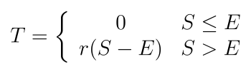

are the typical way of writing a piecewise-linear model, but they are not very handy for use in Excel, especially if you get to 3 or more cases. Instead, it is easier to use the MAX() and MIN() functions in Excel. The MAX() function computes the MAXimum of its inputs. For example, if you type =MAX(3,7,2) it will give back the 7, since that is the largest value. Other examples: =MAX(5,-10,3,0.1) gives 5, and =MAX(0,8) gives 8, and =MAX(0,-8) gives 0. The MIN() function works in a similar way, but gives back the MINimum (smallest) of the numbers you give it: =MIN(3,7,2) gives 2, =MIN(5,-10,3,0.1) gives -10, =MIN(0,8) gives 0, and =MIN(0,-8) gives -8.

It is helpful to think of the T formula above this way: for S values below E, the slope is 0; above E, the slope changes from 0 to r. This is, in some sense, an “extra” rate of r on top of the previous rate of 0. And S-E is the amount we are above E.

In the above formula, suppose E=10000 and r=15% or 0.15. We can graph the two halves (top case for S<=E and bottom case for S > E) separately, and even include values that are outside the stated conditions of S<=E and S>E:

|  |  |  |  |
| --- | --- | --- | --- |
| S | S<=E case | S>E case | actual T |
| 0 | 0 | -1500 | 0 |
| 5000 | 0 | -750 | 0 |
| 10000 | 0 | 0 | 0 |
| 15000 | 0 | 750 | 750 |
| 20000 | 0 | 1500 | 1500 |

Notice that at any particular S value, the true T value (dashed blue line) is whichever of the other two lines (yellow, for S<=E, or red, for S>E) is higher—that is, the maximum. So, we could write this formula as MAX( 0 , r*(S-E) ) in math terms, or =MAX( 0 , 0.15*(A8-10000) ) in Excel if we started on row 8. And then we realize we can move the 0.15 outside the MAX and write =0.15*MAX(0,A8-10000). This means we don't have to remember that inner pair of parentheses. Note that we use MAX because the graph of the true T value is concave-up. That is, its slope increases as you move to the right. This is like the opposite of bulk-discounts, but it is typically for progressive taxation systems.

If the tax is regressive, or if you do indeed get bulk discounts, then you would use MIN. For example, the current system for social security taxes is roughly: 6.2% of your yearly income up to $106,000 and after that, no incremental taxes. We could express this as: =0.062 *MIN( A8, 106000) if the yearly income was in cell A8.

If there is a 2nd bend in the function, for example at an income of $20,000, we can include that in the following way: suppose the rate goes from 15% to 18% once you cross $20,000. This is a 3-percentage-point additional rate. Below $20,000 though the 3% rate does not apply. So we can write a formula for the additional amount paid: =0.03*MAX(0, A8-20000 )

We would then add this to the amount paid above, for an overall formula of

=0.15*MAX( 0 , A8-10000 ) + 0.03 * MAX(0, A8-20000 )

Consider this data set:

<http://www.mlive.com/news/detroit/index.ssf/2015/02/academic_state_champs_top_scho.html#incart_related_stories>  
at 1:47 in the video  
<http://video-embed.mlive.com/services/player/bcpid1949050400001?bctid=4020615771001&bckey=AQ~~,AAAAQBxUr7k~,PsMaWpexSO1o2JBTRvXgK2F46WvPiWEP>  
  
Total family size;free lunch or milk; reduced price lunch  
1;15171;21590  
2;20449;29101  
3;25727;36612  
4;31005;44123  
5;36283;51634  
6;41561;59145  
7;46839;66656  
8;52117;74167

# Chapter 5.3: Expected Value

Is paying for extended warranties worth it? Experts generally say no

<http://national.deseretnews.com/article/5338/is-paying-for-extended-warranties-worth-it-experts-generally-say-no.html>

# Chapter 6.1: Histograms

What, if anything, is wrong with this histogram?

(data are from http://www.census.gov/hhes/www/cpstables/032009/hhinc/new06_000.htm

And have not been altered at all)

And a zoom-in:

(data from the same source, but Prof. Ross did some interpolation on the large bins)

[http://cameron.econ.ucdavis.edu/excel/ex11histogram.html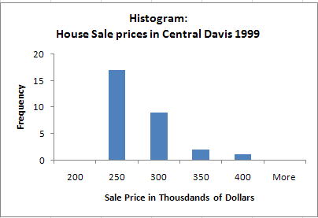](http://cameron.econ.ucdavis.edu/excel/ex11histogram.html)

The # of bedrooms has a mean of 3.03 and a median of 3 for this data set. Is the histogram skewed?

The mean square footage is 1,976 and the median is 1,462. Is the histogram skewed?

The mean selling price is $497,320 and the median is $429,000. Is the histogram skewed?

Here is some data that is skewed the other way: from a Math 110 midterm exam

And the same data, but with bins of width 5:

Age distribution—Population Pyramid, <http://en.wikipedia.org/wiki/Population_pyramid>

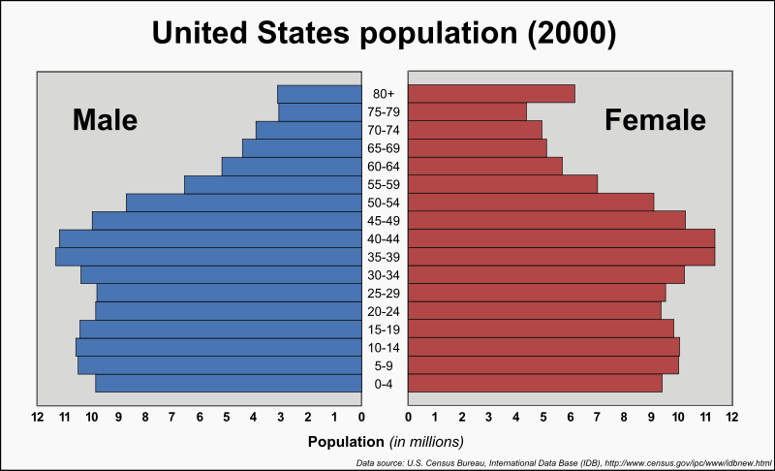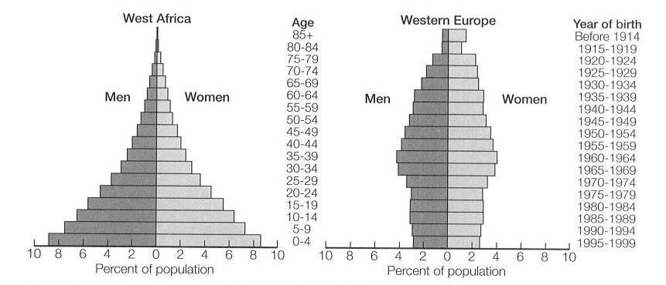

http://en.wikipedia.org/wiki/File:Travel_time_histogram_total_n_Stata.png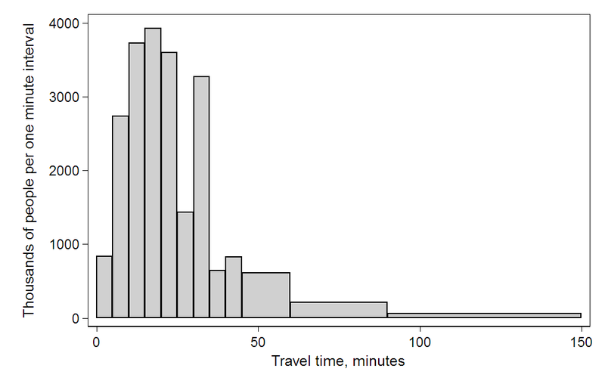

Baseball Statistics

<http://www.hardballtimes.com/main/article/runs-per-game/>

“all the game results from 2000 through 2004: a total of 12,142 games, or 24,284 different instances of runs scored. (God bless [Retrosheet](http://www.retrosheet.org/)). I then added up the number of games in which teams scored a specific number of runs. Here's the result:  
  
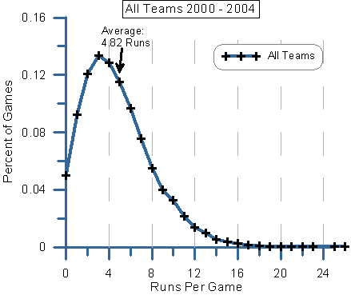  
  
There was an average of 4.82 runs per game scored during these five years, but you can see that the most frequent numbers of runs scored were three (13.4%), four (12.9%) and two (12.1%). In other words, the most common numbers of runs scored were all less than the overall average.  
  
There's a simple explanation for this: teams can't score fewer than zero runs, but they can score as many as the opposition will allow. In other words, there is a lower limit on runs scored, but no upper limit. “

The article then goes on to examine individual teams in individual years:

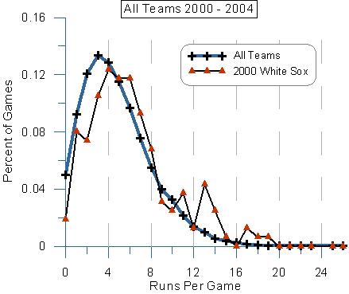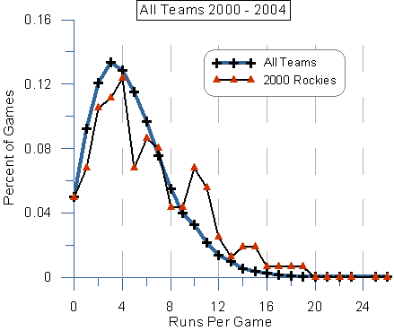

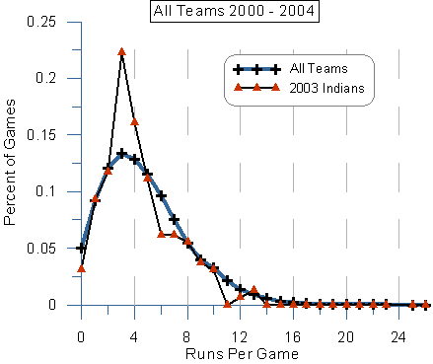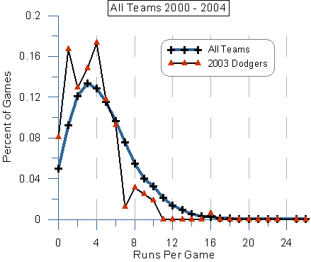

One of the main points is that even though the overall histogram looks fairly smooth, the individual team histograms are a bit rougher, mostly because of the smaller sample size (fewer games played by one team than by the whole league)



Starting salary in for lawyers in 2006:  
<http://www.nalp.org/apictureworth1000words>

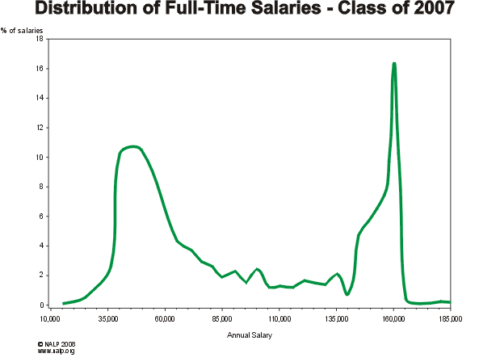

Math 110 Ch 3.5: Correlation, Etc. Name:______________

The book “Born to Buy” by Juliet B. Schor (2004) talks about how companies are marketing toys and foods to children.

1. On page 125 it says “In the 1970s, Marvin Goldberg studied differences between children who saw and did not see television advertising and found that sugared cereals were more likely to be present in the homes of the former.” Is this evidence that food marketing to children is effective? Explain.
2. On page 128, paraphrased the way a reporter might paraphrase it: “A two-year study of eleven and twelve year olds, discovered that each additional soft drink consumed per day increased the likelihood of a child's becoming obese by 60 percent.” What do you think of this study, the way it is summarized here?
3. Here is what it actually said on page 128: “A two-year study of eleven and twelve year olds, which controlled for exercise, other food intake, and media viewing, discovered that each additional soft drink consumed per day increased the likelihood of a child's becoming obese by 60 percent.” Now what do you think?
4. Newsweek reported on July 12, 2010: “Five experiments by Northwestern’s Adam Galinsky showed that those who have lived abroad outperform others on creativity tasks.” Does this mean that living abroad increases creativity? Explain.
5. Newsweek reported on July 12, 2010: “According to University of Texas professor Elizabeth Vandewater, for every hour a kid regularly watches television, his overall time in creative activities—from fantasy play to arts projects—drops as much as 11 percent.” Does this mean:

a) The R^2 value in this study is 0.11? b) The slope in this study is 0.11? c) The slope in this study is -0.11? d) The intercept in this study is 0.11? e) something else? What?